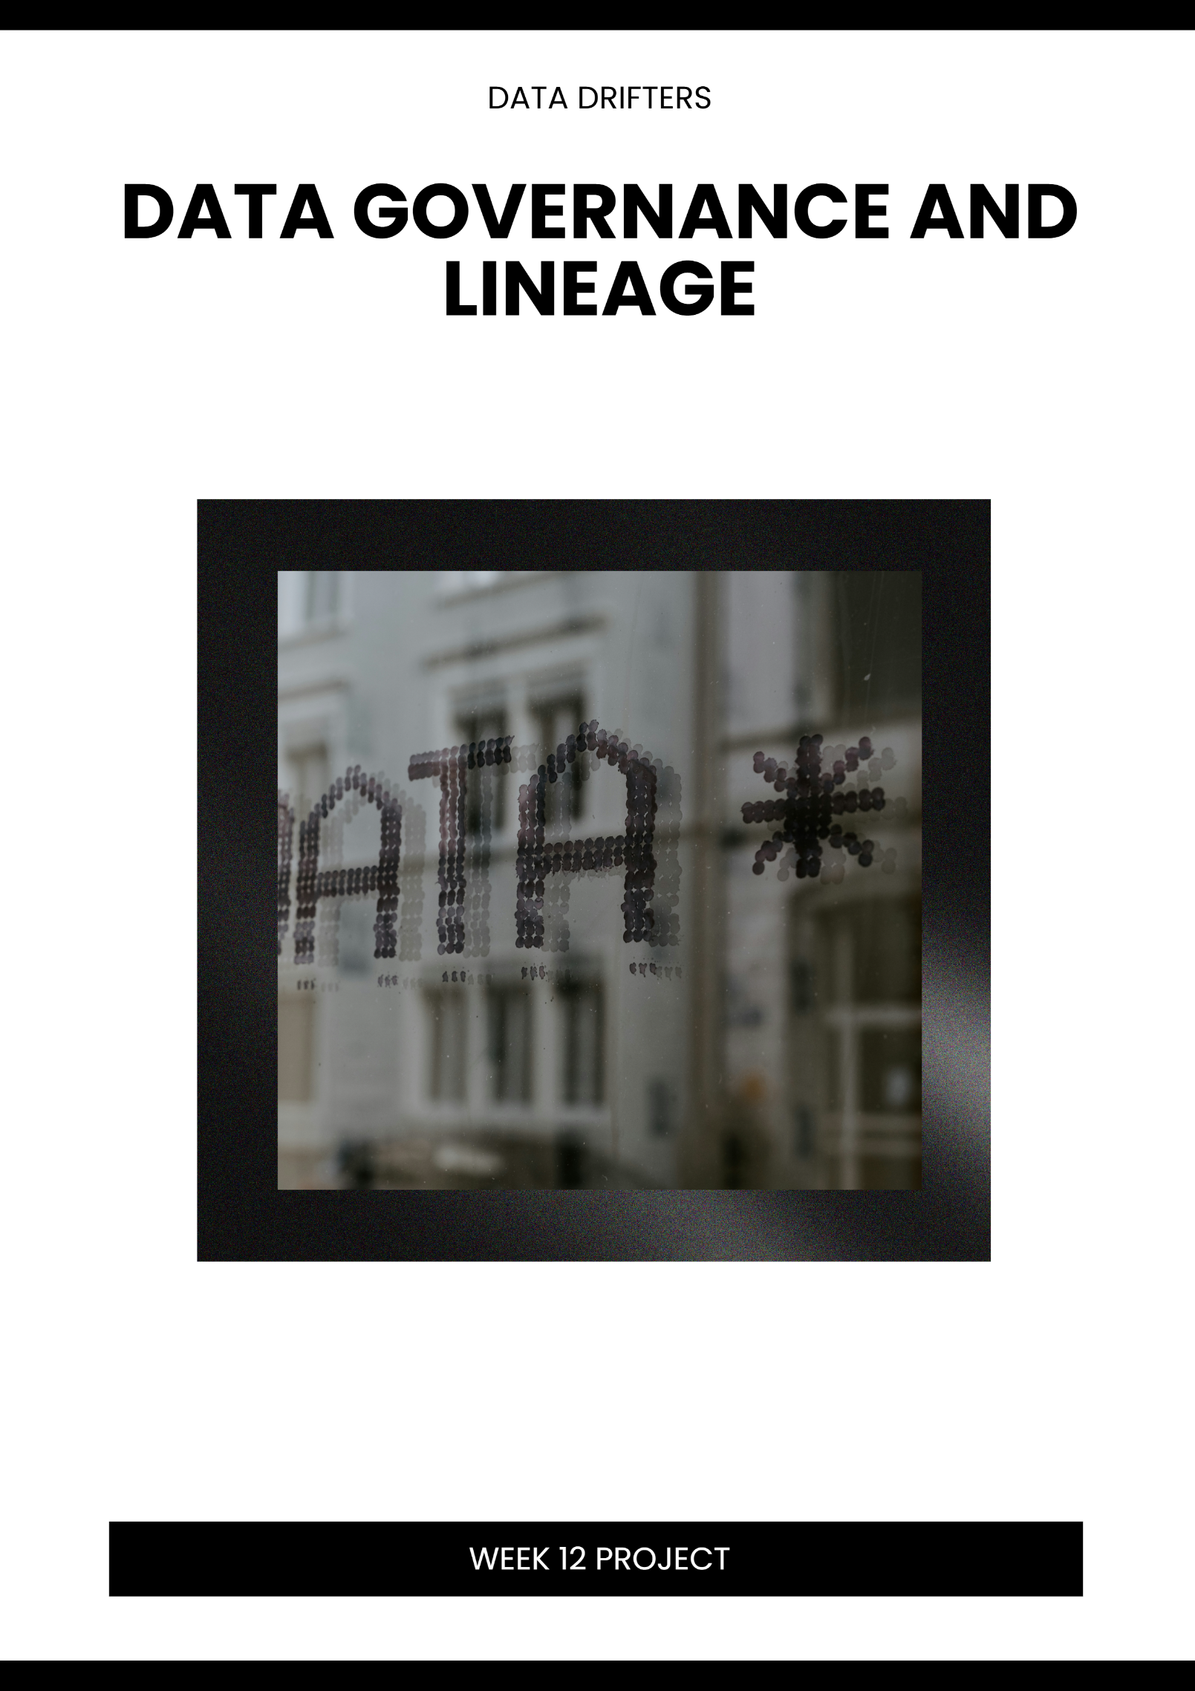

Contents
1. Case Study Overview 2
2. Key Governance Issues 2
2.1 Lack of Access Control 2
2.2 Poor Documentation 2
2.3 Inconsistent or Duplicated Data 3
3. Power BI Solutions 4
3.1 Role-Level Security (RLS) 4
3.2 Data Lineage (Data Flow Documentation) 4
3.3 Workspace Roles and Permissions 4
4. SFIA Alignment (DATM) 6
4.1 Data Integrity 6
4.2 Data Lifecycle Management 6
4.3 Governance Compliance 6
5. Summary 7
Reference List 8

1. Case Study Overview
The UK Post Office Horizon IT Scandal is one of the most significant and widely studied failures of analytics and data governance in recent history. Although the underlying Horizon accounting system was deployed in the early 2000s, the governance failures, including lack of access transparency, poor audit trails, inconsistent data, and suppression of discrepancies, continued actively through the 2020s, culminating in a major public inquiry launched in 2021 and ongoing criminal exonerations through 2024.

Attribute | Details
Organisation | UK Post Office Ltd (publicly owned)
System | Horizon IT (developed by Fujitsu)
Period of Failure | 2000–2024 (governance failures active in last 5 years)
Scale | Over 900 sub-postmasters wrongly prosecuted
Inquiry | Post Office Horizon IT Inquiry (2021–2024)
Financial Impact | £1 billion+ in compensation and legal costs

2. Key Governance Issues

2.1 Lack of Access Control
Fujitsu engineers held undisclosed remote access to branch accounting terminals. This access was never formally documented, audited, or disclosed to sub postmasters or courts. There were no role-based restrictions preventing backend data modifications, and no access logs were surfaced to branch operators.

Access Control Failures
• Undocumented remote access by Fujitsu engineers to live transaction data
• No role-level separation between read, write, and administrative privileges
• Sub-postmasters had no visibility into who could access or alter their accounts
• Audit logs existed internally but were withheld from legal proceedings

2.2 Poor Documentation
Known bugs and discrepancies in the Horizon system were logged in a private database called Peaks. These records were never shared with sub-postmasters or their legal teams. There was no standardised documentation process for data anomalies, and no lineage records showing where figures originated or how they were modified.

Documentation Failures
• Bug database (Peaks) kept secret, over 900 known faults never disclosed
• No data lineage documentation showing the origin of financial figures
• No change logs accessible to branch operators or independent auditors
• Absence of standardised metadata management across the system

2.3 Inconsistent or Duplicated Data
Horizon regularly produced unexplained shortfalls that appeared only in branch-level views but not in Fujitsu's backend records. Duplicate transaction entries caused financial discrepancies that were attributed to human error rather than system faults. There was no single source of truth, different stakeholders saw different data views with no reconciliation process.

Issue Type | Manifestation | Impact
Duplicated transactions | Payments recorded twice at branch level | False shortfalls shown to postmasters
Inconsistent views | Branch data differed from Fujitsu records | No single source of truth
Unexplained adjustments | Figures changed without audit trail | Prosecutions based on false data
No reconciliation | Discrepancies not investigated | 900+ wrongful prosecutions

3. Power BI Solutions

3.1 Role-Level Security (RLS)
Power BI's Row-Level Security feature would have directly addressed the access control failures in the Horizon case. RLS allows administrators to define data access rules tied to user roles, ensuring that each stakeholder only sees data relevant to their function.

Stakeholder Role | RLS Configuration & Access Scope
Sub-postmaster | View own branch transactions and balance summaries only
Regional Manager | View aggregated data for assigned region; no branch-level edit access
Finance Auditor | Read-only access to all branches; full transaction history with timestamps
IT Administrator | System health metrics only; no access to financial transaction data
Executive (Read-Only) | High-level KPI dashboards; no access to individual records

With RLS enforced, Fujitsu engineers would have had clearly defined and logged access scopes. Any data modification would have been attributed to a specific authenticated identity, creating a tamper-evident audit trail.

3.2 Data Lineage (Data Flow Documentation)
Power BI provides native data lineage views within its workspace interface, showing the full flow of data from source systems through transformations to final reports. This addresses the documentation failures central to the Horizon scandal.

Power BI Lineage Features Applied to Horizon
• Source tracking: Each dataset linked to its origin (branch terminal, batch upload, API)
• Transformation log: All Power Query (M) steps documented and version-controlled
• Dataset impact analysis: Changes to upstream data flagged before affecting downstream reports
• Endorsement labels: Certified vs. unverified datasets clearly distinguished
• Lineage view in Power BI Service: Visual map from data source to dashboard

Had lineage documentation been in place, the Peaks bug records would have been formally linked to affected datasets, making it impossible to present financial reports without disclosing known data quality issues affecting those figures.

3.3 Workspace Roles and Permissions
Power BI Workspaces support a structured permission hierarchy that maps directly to organisational accountability. The following workspace role model would enforce governance across the Post Office analytics environment.

Workspace Role | Permissions | Applied To
Admin | Full control; manage membership | Head of IT Governance only
Member | Publish & edit content | Senior data engineers (audited)
Contributor | Create reports; cannot publish | Analysts and branch data teams
Viewer | Read-only dashboard access | Sub-postmasters, legal auditors

Workspace roles would have ensured that Fujitsu engineers could not modify production data without an Admin-level approval workflow, and that any access attempt was logged with a timestamp and user identity.

4. SFIA Alignment (DATM)
The proposed Power BI governance solution aligns with the SFIA (Skills Framework for the Information Age) DATM competency, Data Management. The three core governance pillars addressed are outlined below.

4.1 Data Integrity
Data integrity ensures that information is accurate, consistent, and trustworthy throughout its lifecycle. In the Horizon case, integrity was fundamentally broken because data could be silently altered with no record of change.

How the Solution Supports Data Integrity
• RLS prevents unauthorised data modification, all writes require authenticated, role-authorised identity
• Lineage documentation creates an immutable record of where each figure originated
• Power BI certified datasets enforce a single verified source of truth
• Data validation rules in Power Query flag anomalies before they reach reports

4.2 Data Lifecycle Management
Data lifecycle management governs how data is created, stored, updated, archived, and retired. The Horizon system had no formal lifecycle policies, bug records were silently deleted, transaction logs were retained selectively, and no retention policy governed what was kept.

Lifecycle Stage | Power BI Governance Control
Data ingestion | Source validation rules in Power Query; certified dataflows only
Active use | Workspace versioning; endorsement labels on published datasets
Archival | Incremental refresh policies with full history retention
Deletion / retirement | Admin-controlled dataset retirement with audit log entry

4.3 Governance Compliance
Governance compliance ensures that data management practices align with legal, regulatory, and organisational standards. The Horizon scandal failed catastrophically on this dimension, evidence was withheld, audit logs were concealed, and there was no compliance framework tying data practices to legal obligations.

Compliance Controls in the Proposed Solution
• Full audit trail in Power BI Activity Log, all access and changes timestamped and attributed
• Sensitivity labels (Microsoft Purview integration) classify data by legal sensitivity
• Mandatory documentation policy: datasets cannot be published without lineage metadata
• Regular governance reviews enforced through workspace access expiry and re-certification
• Legal hold capability: datasets tagged for active litigation cannot be modified or deleted

5. Summary
The UK Post Office Horizon scandal demonstrates that BI governance failures are not merely technical oversights, they have profound human and legal consequences. The absence of access controls, data lineage documentation, and consistent data management enabled systematic injustice to persist for over two decades.

The Power BI governance framework proposed in this report, combining Role-Level Security, native data lineage, and structured workspace permissions, directly remedies each identified failure. When aligned to SFIA DATM competencies, this framework supports data integrity, data lifecycle management, and governance compliance at an organisational level, ensuring that analytics systems are not only powerful but trustworthy and accountable.

Reference List
Castles, B. (2024). Post Office Horizon IT inquiry: Final report. UK Government. https://www.postofficehorizoninquiry.org.uk
Fujitsu. (2024). Horizon IT system: Technical overview and known defects. Fujitsu Limited.
Microsoft. (2024). Row-level security (RLS) with Power BI. Microsoft Learn. https://learn.microsoft.com/en-us/power-bi/enterprise/service-admin-rls
Microsoft. (2024). Data lineage in Power BI. Microsoft Learn. https://learn.microsoft.com/en-us/power-bi/collaborate-share/service-data-lineage
Microsoft. (2024). Roles in workspaces in Power BI. Microsoft Learn. https://learn.microsoft.com/en-us/power-bi/collaborate-share/service-roles-new-workspaces
SFIA Foundation. (2024). DATM — Data management: Skills framework for the information age (version 9). SFIA Foundation. https://sfia-online.org/en/sfia-9/skills/data-management
Wallis, R. (2023). The Post Office scandal: How Horizon destroyed lives. BBC News. https://www.bbc.co.uk/news/business-56718036
Wright, K., & Bohm, N. (2022). Broken code: Inside the Post Office's battle to bring down its own workers. Penguin Random House.

